Group(組別): ___________ Member(組員)：__________, __________, __________, __________

Imagine you are in London now. You hope your friends in London can come to Penghu one day.
So you take an online trip to Penghu together.
每組用google maps搜尋澎湖。畫出景點地圖。仿課文寫出線上旅遊的路線。
Example:
My friends in London and I took an online trip to (1) _Magong City_ in Penghu.
We started from (2) _ Penghu Visitor Center _ because _it’s in the center of Mogong City_. We went (3) __west__ and see (2)_ Penghu Living museum _. It’s _very big__. After that, we went (3) _south_ and see (2) _ Fongguei Cave _. It’s _very special_.
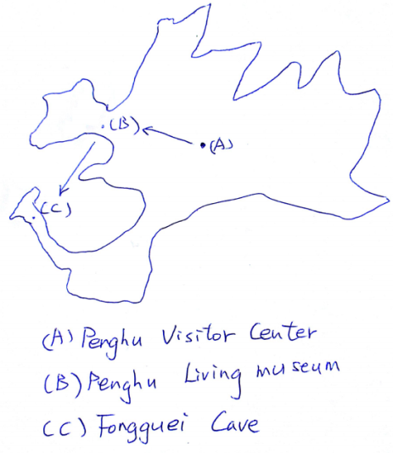
Penghu is really a beautiful place. I hope they can come to Penghu in person one day.
參考字彙
(1) 地名：Magong City/ Huxi/ Baisha/ Xiyu/ Qimei Island/ Ji-bei Island/ Wangan Island
(2) 景點：(以馬公市為例) Penghu Visitor Center/ South Sea Visitor Center/
Fongguei Cave/ Snakehead Hill/ Tongpan Geology Park/ Shihli Beach/ Shanshuei Beach/
Hujing Recreation Area/ Penghu Living museum/ Mazu Temple
其他各地景點，請參考交通部觀光局澎湖國家風景區網站英文版
（http://www.penghu-nsa.gov.tw/english/QuickSearch.aspx?appname=QuickSearchE）
(3) 方向：east/ west/ south/ north

